Movie Ticket Booking System

1. **Creating the tables**

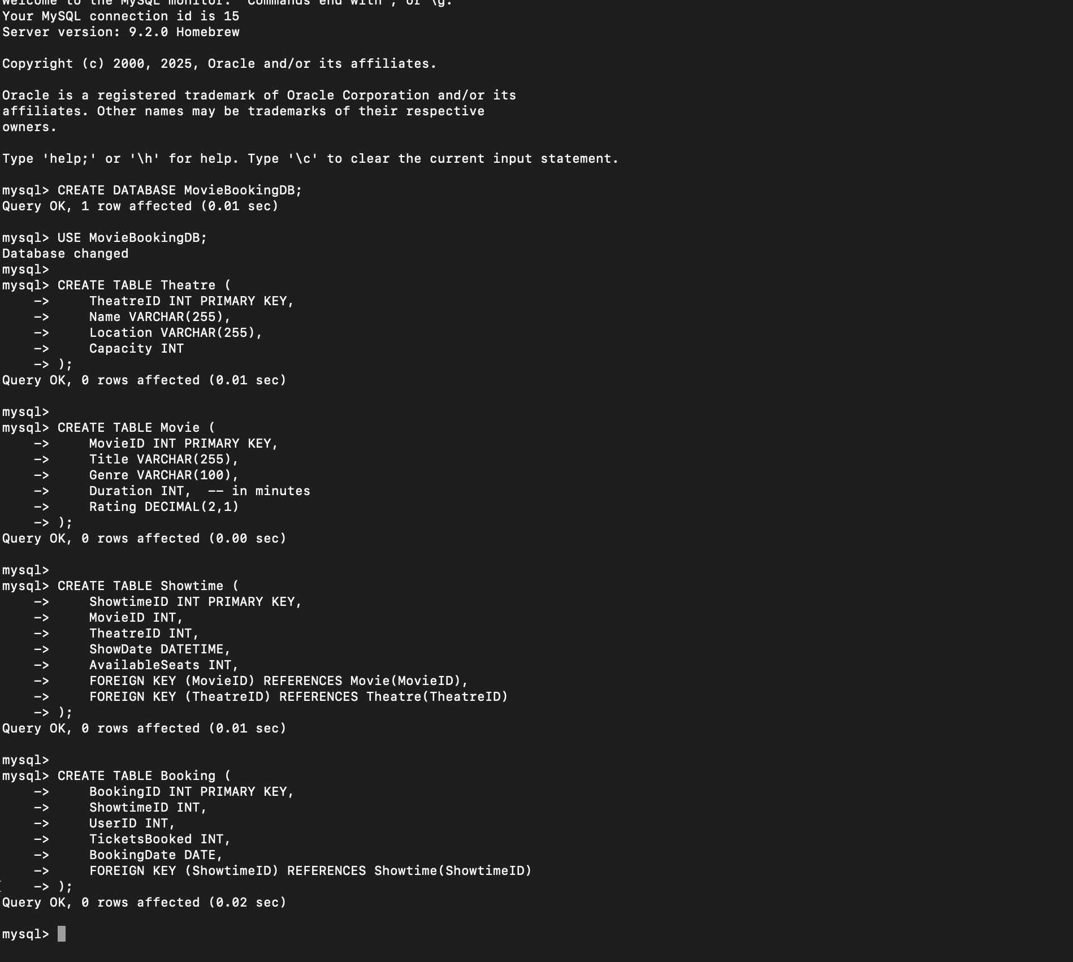

1. **Inserting sample data**

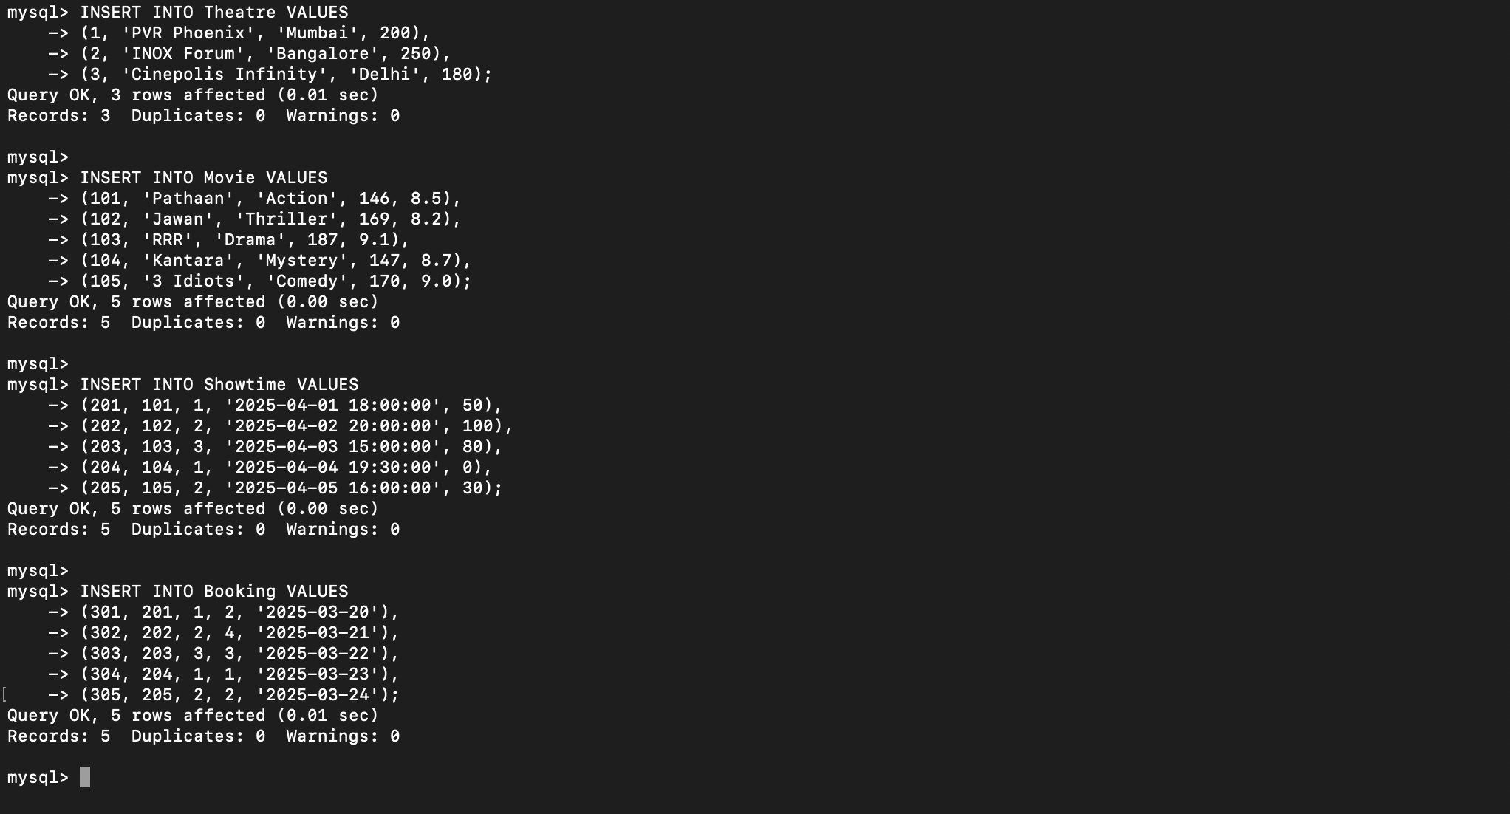

1. **Retrieve all movies available in a specific theatre**

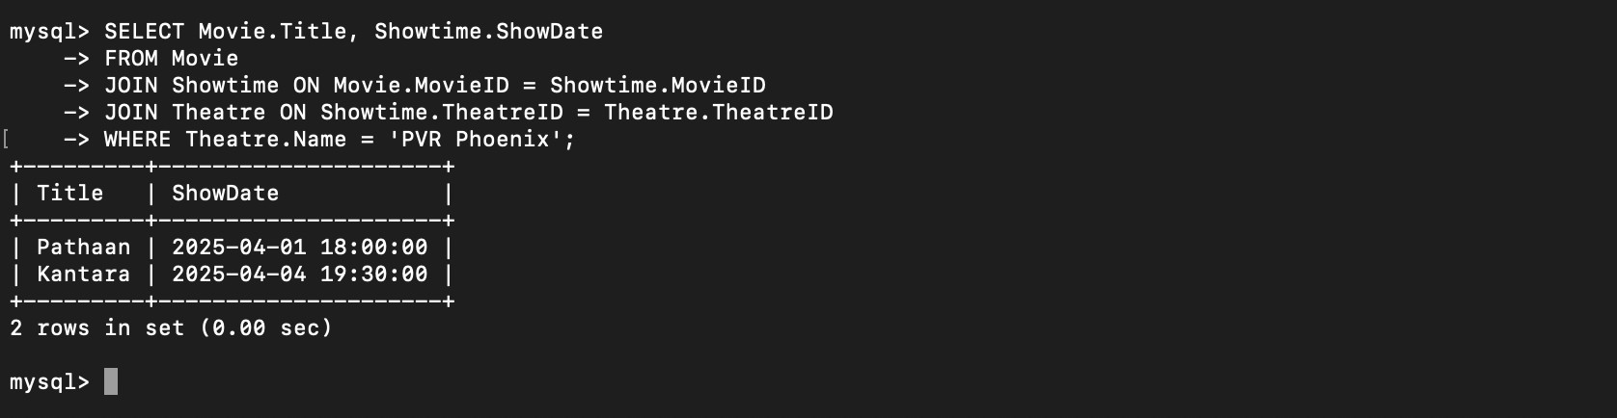

1. **Find the most booked movie in the last month**

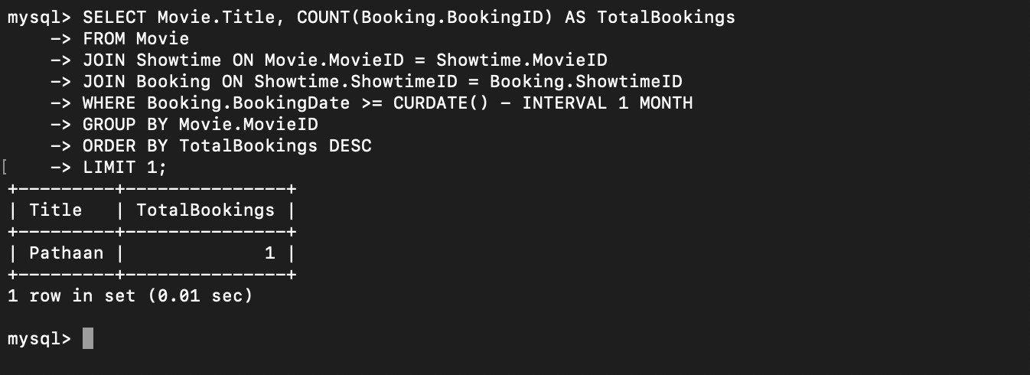

1. **Retrieve showtimes with available seats**

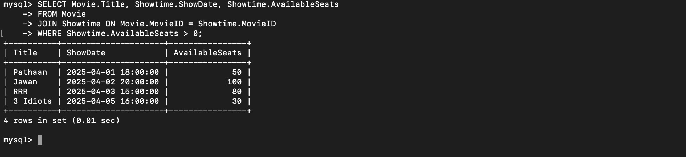

1. **Find theatres with the highest bookings**

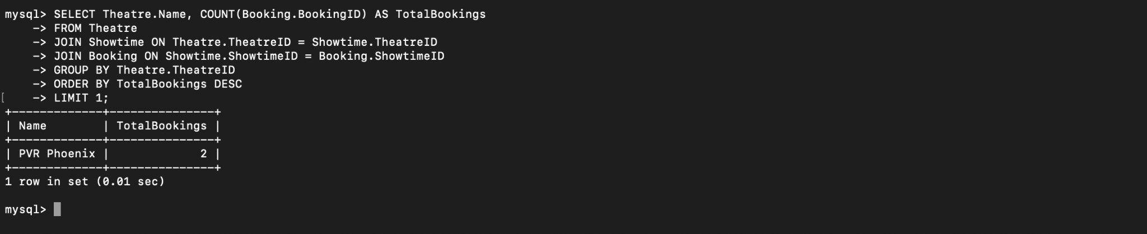

1. **Display user bookings in the last 3 months**

